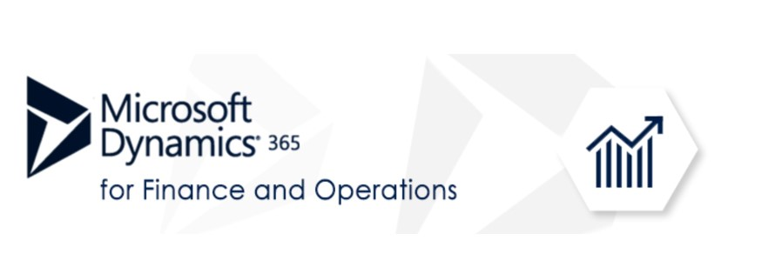

|  |
| --- |
| **MS Dynamics 365 - AX 7 Technical Curriculum**  **[Finance and Operations]** |

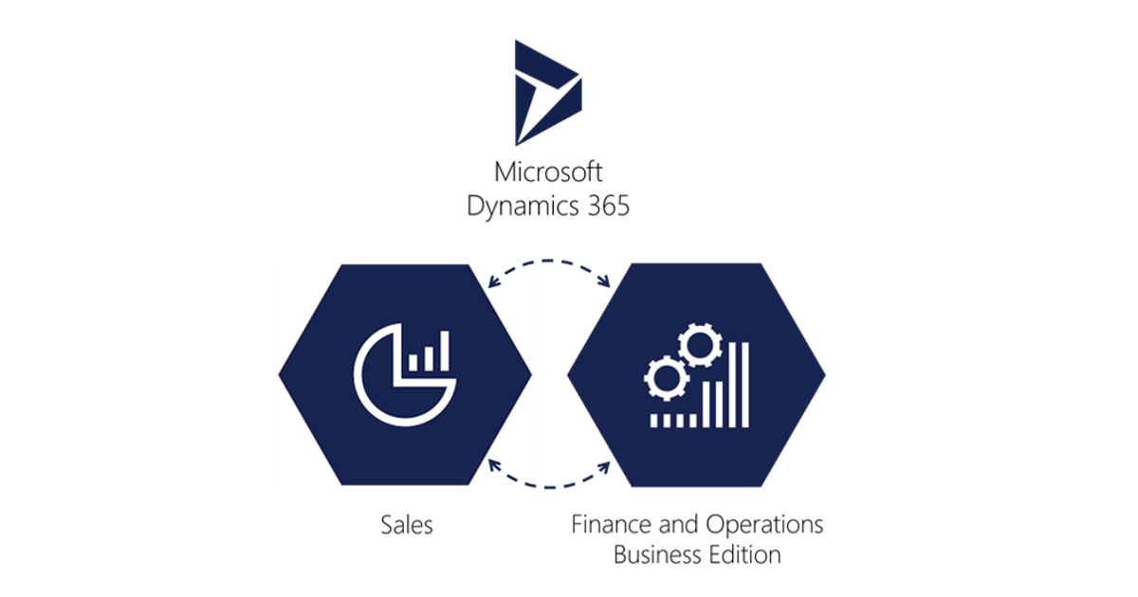

|  |
| --- |
| Microsoft Dynamics 365 for Finance and Operations (formerly called Dynamics AX) is Microsoft's Flagship Enterprise Resource Planning (ERP) suite. Seamless integration with Dynamics 365 Customer Relationship Management (CRM) Apps and Office 365 enables faster business processes and smarter decision making. |

|  |
| --- |
| **MS Dynamics 365 - Finance and Operations** |

1. **Introduction**

* Creating Visual Studio Team Services Project
* Connecting Visual Studio To Visual Studio Team Services
  + Patching AX With Metadata Updates 11
  + Patching AX With Binary Updates
* Creating A New Model And Package
* Configuring Project And Build Options
* Creating a Label File

1. **Data Structures**

* Creating Enumerated Types
  + Using Enums For Comparison and Status
  + Extensibility In Base Enums
* Creating Extended Data Types
* Creating a Set Up And Parameter Tables
  + Copying And Pasting Methods to Save Time
  + Optimistic Concurrency And Selectforupdate
* Creating Main Data Tables
* Creating Order Header Tables
* Creating Order Line Tables

1. **Creating User Interface**

* Creating Menu Structure
* Creating a Parameter Form
* Creating Menu Items
* Creating Set Up Forms
* Creating Details Master (Main Table) Forms
* Creating a Details Transaction (Order Entry) Forms
* Creating Form Parts
* Create Tiles With Counters for the Workspace
* Creating a Workspace

1. **Creating Business Logic**

* Creating a Handler Class Using the Application Extension Factory
* Hooking Up a Number Sequence
  + Number Sequence Set Up
  + Hooking Up the Number Sequence
* Creating a Create Dialog for Details Transaction Forms
* Creating a Sysoperation Process
  + Executing Code Using the Batch Framework
  + Calling a Process From a Form
  + Using the Data Contract to Make Changes to the Dialog
* Adding an Interface to Sysoperation Framework

1. **General Customize & Development**

* Introduction of Dynamics 365 F&O, Concept of Layer, Models, Packages and Use of Extension upon Over Lying. Use of LCS In D365
* AOT Objects Tables, Properties of Table, Relations, Best Practices and methods, Security
* EDTS, ENUM, Views, Maps, Query
* Methods over Form and Tables
* Lookup, Event Handler, Events and COC
* Classes and Query Classes, Extension Classes, Implement Classes
* SSRS Reports
* Sys Operation Frame Work
* Workflows and Power BI

1. **Security**

* Creating Privileges
* Creating Duties
* Creating Security Roles
* Creating Policies

1. **Leveraging Extensibility**

* Extending Standard Tables Without Customization Footprint
* Creating Data Event Handler Methods
* How To Customize a Document Layout Without An Over-Layer
* Extending Standard Forms Without Customization Footprint
* Using a Form Event Handler To Replace A Lookup
* Using Form Parts To Add Re-Useable Content To Standard Forms
* Other Types Of Extension
* Creating Event Handler Methods
* Creating Your Own Query Functions

1. **Data Management, Odata, and Office**

* Creating Data Entities
* Extending Standard Data Entities
* Importing Data Through Data Import/Export
* Reading, Writing and Updating Data Through Odata

1. **Consuming and Exposing Services**

* Creating A Service
* Consuming a Dynamics 365 For Operations Soap Service
* Consuming a Dynamics 365 For Operations Json Service
* Consuming an External Service Within Dynamics 365 For Operations

1. **Leveraging Advanced Features**

* Using Metadata For Data Access
* Using Interfaces For Extensibility Through Metadata
* Using Metadata To Access Business Logic
* Making Data Date-Effective